BEFORE YOU START

Most of our dogs require fencing of 6 feet. The MINIMUM fencing requirement is 4 feet. The garden must be secure and completely enclosed.
You MUST have a garden. We do consider shared gardens, but these too must be secure with suitable fencing.

Chicken wire, barbed wire, expanding trellis, netting, non-rigid wire, plywood, MDF and bamboo or willow screening are NOT SUITABLE and will not pass a home check.

Please make sure items are removed from the boundary. A dog can use these to escape over the fence. This includes garden furniture, compost bins, wheelie bins, play equipment, trampolines, raised flower beds, barbecues, bird baths, storage sheds, rabbit hutches and piles of bricks or logs.

We do not adopt dogs to flats with balconies because this presents a falls risk.

We do NOT adopt to homes with children under 5 years old.

We will consider applicants who work full time but there MUST be provisions in place for the dog to be cared for whilst you work. For example, a dog walker, day care or sitter. We ask that you consider this before you apply.

YOUR NEW RESCUE DOG.
WHAT TO EXPECT

Thank you for applying to adopt a dog with us. By adopting you are giving a rescue dog the chance of a happy life and creating a shelter place for a second rescue dog who will now be safe.

Please read through this document carefully before committing to adopt a dog. Moving to a new home can be very stressful for a rescue dog so please consider the following advice to ensure you are able to dedicate the time, patience and love necessary to fully rehabilitate a rescue dog into their new, loving forever home.

The following advice is provided in conjunction with the Terms & Conditions of adoption.

WHAT YOU WILL NEED

You will need some equipment for your new dog. Most things can be found by asking friends or family members to donate things. Your dog will not care what any of it looks like or what colour it is.

WE RECOMMEND
- Slip lead – this is essential to prevent your dog slipping the collar or harness and is used only in emergencies.
- Adjustable collar + ID tag
- Harness & flat lead NEVER AN EXTENDING LEAD. We recommend a 3 point harness which is much more secure than other harnesses.
- Crate (always go bigger if unsure)
- Old towels and blankets for a bed
- Two bowls, one for food and one for water.
- Food of your choice (see feeding advice below)
- Toys/chews
- Shampoo (any dog shampoo)

There is no need to buy anything fancy. Especially not a bed which could end up chewed, peed on or destroyed. Plastic dog beds are durable, resistant to chewing and easy to clean.

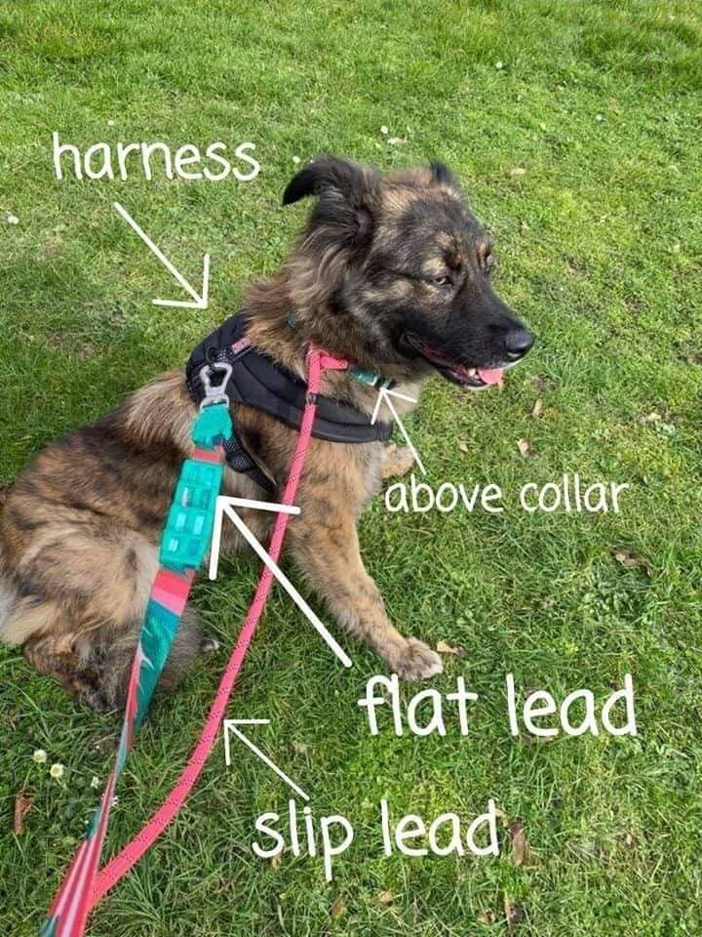

PAPERWORK

Foreign rescue dogs have a passport which contains a record of vet checks, vaccinations, microchipping, flea and worming treatments. There may be a record of blood testing or neutering but not always.

UK rescue dogs will have a vaccination card. There may be additional paperwork relevant to that dog.

Please keep all your paperwork safe. If you have any questions about paperwork please ask.

MICROCHIPS & TAGS

Your dog’s microchip will be re-registered to you when you complete the adoption contract.

It is a legal requirement for dogs in any public place to wear a collar with a tag clearly stating the name and address of the owner. Your telephone number is optional, but advisable.

TRIALS

We want all adoptions to be succesful ones. All adopters are offered a no obligation seven day trial period. This enables you to be certain that your new rescue dog is a good fit.

You are under no obligation to adopt the dog who can be returned to their foster home. You will be fully suported throughout the trial period. You will be provided with a trial dicument which explains your dog’s needs in detail. This will help your trial period to be succesful. If you decide not to adopt the dog you must return the dog as soon as possible to the foster home you collected them from.

If you do decide to adopt, the adoption fee is payable immediately. There is an adoption contract to complete to finalise the adoption. Please remember that adoption fees, once paid, are not refundable.

ADOPTION CONTRACT

When you receive your dog, you need to complete an adoption contract online. This can be found at www.phoenixrehoming.co.uk/forms. This contains information unique to the dog including when their vaccines are due.

Once the contract is completed, the team will re-register the microchip into your details and activate 5 weeks FREE pet insurance with Agria.

We will ask for a good photograph of your dog for their adoption post.

SETTLING IN

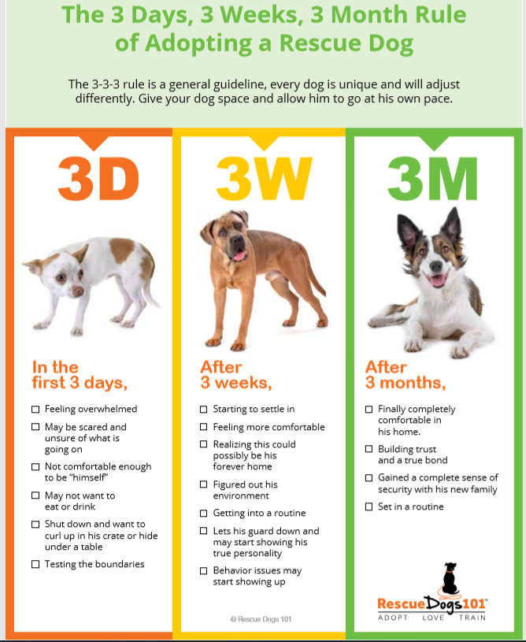

TRAVEL SAFETY

The highway code (rule 57) states:
“When in a vehicle make sure dogs or other animals are suitably restrained so they cannot distract you while you are driving or injure you, or themselves, if you stop quickly. A seat belt harness, pet carrier, dog cage or dog guard are ways of restraining animals in cars.”
Rescue dogs are often nervous of travelling, especially foreign rescue dogs who have travelled thousands of miles to get to the UK initially.
We recommend that your dog is either restrained with a seatbelt and harness or inside a crate. It can help to have someone to sit near them to offer reassurance. Car sickness is very common, you might notice excessive drooling, panting and whining so make sure you plan breaks if your journey home is long and use towels or blankets to make cleaning easier of your dog is sick.

LEAVE A LEAD ON WHEN YOU ARRIVE HOME
Leave a short lightweight lead trailing when you first arrive home in case you need to move your new rescue dog off of, out of or into anywhere This will eliminate the need for you to grab for their collar, which could be scary to an already stressed dog that doesn’t know you very well.

TIME, SPACE & PATIENCE
When your dog arrives, however calm they may have been in previous meetings, moving to a new home can put them into stress overload, causing their Cortisol and Adrenaline (stress hormones) levels to raise through the roof. They will need at least a few days for these to even begin to come down so please do make these first few days very calm.
Make sure they have a place they can be that is away from lots of noise and if necessary, give them separate time from resident dogs to have a break and process their new surroundings. If they are fearful when they arrive and don’t wish to interact then leave them to choose their space and don’t keep encouraging them to make friends. They will come around in their own time but if you keep trying to make them do things you could increase their anxiety and make the process of them settling take much longer, just getting on with your day around your new dog can help them to adjust to their new forever home.

PREVENT OVERWHELM
Avoid having lots of visitors to the house during the first week. Let your new arrival settle, get used to their new environment and get used to you before you start introducing more new people. Visitors tend to want to excessively fuss because they will know you rescued this dog from an awful situation. All this attention from so many strangers can cause many of these dogs to feel anxious. Let your dog choose to interact with any visitors when they do come, but if they don’t want to then leave them be and ask your visitors to ignore them. You should be able to tell how comfortable they’re feeling from their body language. If they’re happily leaping around your new visitors, then it’s more likely they will enjoy a fuss, but if they’re hesitant and unsure, it is REALLY IMPORTANT that you let your dog set the pace for new introductions. If you try to encourage them to make friends, you can MAKE them scared of new people and this can take months to change once established.

SAFETY
Keep them on a lead, preferably a long line in the garden for the first few days, some dogs can be very panicked by all they’ve been through & their new surroundings and you want to be sure they have no intention of trying to escape. This is especially important and a very real possibility if your new rescue dog was a street dog. Some of these dogs have been reported to jump 6-foot fences and if you have any gaps in your fencing, you can be sure your dog will find them!

BELT & BRACES ON YOUR FIRST WALKS
Double lead your rescue dog when you first start walking them outside, in case they panic and slip a collar or harness. The best combination is harness (a 3 point or ‘Y’ style harness is best, look for something that doesn’t restrict the dog’s leg movement and is difficult to back out of) and a slip lead on as well as your ordinary collar. Don’t use the slip lead, it’s only there as a back-up if anything goes wrong. Many rescue dogs will panic if you use a lead that tightens around their neck so make sure the slip lead is only used as a backup emergency. DO NOT USE EXTENDING LEADS.
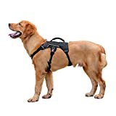

If possible, keep walks close to home for at least the first week. Keep your initial walks to short walks around your local area so they get used to their new surroundings. Go with the comfort zone of your dog, however great they were with their foster they to an extent will now need to start again with a new area, new rules, new hazards. Your dog’s foster carer will be honest with you about any additional lead training the dog needs. Please follow advice and continue lead training. Don’t be surprised if some issues arise when you walk them in brand new surroundings for the first time. Do plenty of lead practise in the garden in the first few days and practice recall without all the distractions they will face when the actually go out for walks.

Don’t Let your rescue dog off the lead for AT LEAST several weeks, but probably much longer & with some never. Hire a secure field if you want to give them a good ‘ole run around. Please do not risk your dog’s life because you want to enjoy the sight of them ‘running free’ many rescue dogs are very easily spooked, and it wouldn’t take much for them to bolt. In addition to that many of them have a very high prey drive and although they may seem like they’re going to hang around with you, one whiff of something interesting and they could well be disappearing into the distance!

VET CARE/HUSBANDRY

DISEASE TESTING
If you have adopted a dog from overseas, they will have been tested for and negative to distemper, parvo virus and brucellosis. All overseas dogs aged over 6 months are blood tested for heartworm, lyme disease, anaplasma, ehrlichia and leishmaniasis. It is not clinically possible to test for these diseases in puppies under 6 months of age.
Every step is taken to ensure dogs are disease free. There are very rare occasions when such diseases are dormant and not identified during testing only to appear later, post adoption. We urge all adopters to carry out their own research about these diseases. Phoenix Rehoming accepts no liability for such diseases which are diagnosed post-adoption.

NEUTERING
Where possible, dogs over the age of 6 months will be neutered according to veterinary advice. Some dogs are unsuitable for neutering until they are older than this. If your dog is not neutered, you have a personal responsibility to ensure your dog is neutered as per your adoption contract following advice from your vet and at your own cost.

FOOD & WATER

Please read our separate guide on feeding.

Make sure your new rescue dog has access to fresh water in a place where ideally, they don’t have to turn their back on a room to drink, so not in a corner. If they feel anxious about their surroundings, they may be reluctant to drink if they can’t see where everyone is while doing so, this also goes for food. Feed your new dog in a separate area to resident dogs/other pets.

Your fosterer will tell you which food your dog is currently being fed on - You are free to feed your dog whatever you choose, however choosing a quality food can have a significant positive impact on a dog’s wellbeing and behaviour.

We do ask that you take the time to look at food reviews at:

www.allaboutdogfood.co.uk

There are some very poor-quality foods which should be avoided. Poor quality food will impact upon health and behaviour. We ask that you avoid Bakers, Wagg, Pedigree, Frolic and own brand supermarket foods where possible. When choosing a food, the first ingredient should always be a high percentage of recognisable meat. We do not recommend rice or pasta being fed.

The team consists of several qualified pet nutrition specialists who are more than happy to give you free help and advice.

RECOMMENDED DON’TS

Don’t keep fussing over your new arrival, they will most likely not be used to it. Although you may feel you are showering them with all the love they have missed out on and comforting them during their stress at being in a new home, they can actually find this quite stressful, in addition to all the stress of their journey and finding themselves in a whole new strange environment. Give them time and space. If you have children, don’t let them bombard your new dog with attention (see prevent overwhelm above) train them how to behave around a dog and how to read their body language. Your dog may want nothing more than to cuddle up with your young children but rescue dogs may have limited experience of children who can be loud and unpredictable. Please teach your children to respect the dog’s space and give your dog somewhere child free to retreat to.

DO NOT have visitors for the first couple of weeks if you can avoid it. We understand, you have a beautiful new dog and you want them to meet everyone who is important to you, but even the bravest, friendliest dogs need time to settle into a new home and new routine.

Don’t bathe them for at least a few days unless they are content to be handled. Please refrain from putting them through the additional stress of being bathed unless it is ABSOLUTELY NECESSARY for medical reasons. This is a very intrusive and often scary experience for a dog that has already been through so much stress. They barely know you or where they are and may not cope at all well with being manhandled into a bath or shower. This kind of overwhelm in the first few days of arriving could easily cause trauma for your new arrival and the development of more deep seated issues (fearfulness, mistrust, reactivity) Once a few days have passed you will have a much better idea of how your dog might cope with this experience (or not as the case may be).

Don’t allow them to follow you everywhere and have access to all areas of the house for the first few days/weeks. Often these dogs will be new to all the home comforts we offer them and if you allow them free rein over everything, you could find them developing resource guarding behaviours over all the new & wonderful ‘stuff’ they find at their paw tips. Plus, it can help prevent the development of separation anxiety by providing them with their own room that you leave now and again just to go to other areas of the house. In addition to this, an anxious dog can feel more anxious if they have too much space.

Speak to your fosterer around whether they have had access to sofas/beds and restrict access to these to begin with if necessary. This can instigate resource guarding, which once it starts to happen, is more difficult to stop than if you can prevent it from starting and being practised in the first place. Resource guarding of sofas and beds is a common problem during the first few weeks.

Remember, your resident pet might be the one showing signs of upset and anxiety because the new dog has arrived. Make sure you are prepared for this and have plans for how you will handle any disagreements. It is always best to offer any high-value treats (e.g. antlers, chews) when dogs have a quiet safe space to eat these in peace without being bothered by anyone.

Don’t mess about with your rescue dog's feet, this is a very sensitive area (instinctively) for dogs, leave grooming, bathing and rubbing with a towel until they are a bit more familiar with you and a relationship of trust has been established. Your new rescue might be overdue for a groom, and whilst some will tolerate being bathed, it could be another stressor for them on top of an already stressful week. If you can leave it a couple of weeks until they are settled, they might feel more comfortable about you doing it/hiring a groomer.

Do your own research on resource guarding, trigger stacking and other problem behaviours.

WHAT TO EXPECT FOR THE FIRST FEW WEEKS

When your rescue dog first arrives with you, it is important to realise they will need time to adjust and settle. If I took one of my dogs and left them in a strange house where they didn’t know anyone, I would expect them to be very unsettled, upset, confused and very stressed, and they may display behaviours which they would not normally display.

I would expect all this from a dog that has never had any upset in their life and has lived knowing nothing but love, safety and security. So, imagine how much worse it is for a rescue dog. Some foreign rescue dogs especially may have experienced terrible things.

Some dogs cope remarkably well moving to a new home, but some don’t.

IMPORTANT POINTS TO REMEMBER IN ORDER TO PROVIDE STRUCTURE IN THE EARLY WEEKS

Have all the equipment you might need ready for when your dog arrives. That way you will be prepared.

Keep YOUR behaviour consistent. Your rescue dog will learn much quicker from knowing what is expected of him. Avoid confusing him by making sure everyone in the house is doing the same things.

Provide a secure, safe place for him to be left alone. Start doing this as soon as he arrives, even if only for 5 or 10 minutes at a time while you go elsewhere in the house. The more times you can repeat this from day one, the better your dog will cope with being left when you must go out for longer periods.

Establish a routine as much as possible and as quickly as possible. Your new arrival can gain a lot of confidence and reassurance from having a routine in place and knowing what to expect and when. This can help them settle more quickly and there will be plenty of time to develop their resilience to changes in routine once they are more settled.

PRE & POST ADOPTION HELP
As part of the Phoenix adoption process, you agree to participate in a pre-adoption video call/phone call before you receive your dog and a follow up video call/phone call any time during the first month after your dog has arrived. The calls are in place to give you and your dog as much support as possible during this in period.
One of Phoenix’s positive qualified dog trainers will call you at a convenient, pre-arranged time.
Ideally the first call would take place before your dog arrives.
The first call will cover:
- Setting you up for success
- Preparing you and your family for the arrival of your rescue dog.
- Do’s and don’ts
- What to expect
- What to do if issues arise
- Advice on what to feed your dog and what equipment to use, such as crate training, collar v harness, the value of a good diet etc
- You will have lots of opportunity to ask questions.
The follow up call after you receive your dog will be tailored around your dog’s needs and specific to anything that they or you may need help with. (Toilet training, sleeping through the night, food guarding, unusual behaviour, being comfortable when you go out etc.)
The call can be at any time during the first month. If your dog settles in well, We will arrange the call for the 3rd or 4th week into adoption.
If any issues or concerns arise soon after adoption, contact your allocated trainer as soon as possible. They will arrange to call you as a priority.

TRAINING

Phoenix Rehoming promotes only positive dog training. You can find help from a positive trainer at https://www.imdt.uk.com/find-a-qualified-imdt-trainer

Expect some problems in the early settling in period and be prepared for it to be a bit stressful and unsettling for everyone in the house to start with. We will provide support and advice. As per your adoption contract it is your responsibility to seek support from a professional if you encounter any behaviour you do not feel equipped to deal with, but if you need help finding this, please JUST ASK!

You will find many training and advice files in the “Life After Rescue” group on Facebook. We can provide all and any of these via email to you. Please just ask.

This Is a Critical Transition Period
Dogs are particularly impressionable when they first arrive in a new environment, and how well you manage their behaviour during this transitional period will have a direct effect on how quickly they settle and become a well-adjusted member of the family. Remember they are leaving an environment they are comfortable with, and know the rules of, to learn to feel comfortable all over again.

Please plan to invest time during this period to socialise, teach and get acquainted with your new dog and his/her unique character.

Remember – rescue dogs are often Trauma Survivors, don’t force interactions think about the following things:
Does my dog consent? | Does my dog feel safe? | What is my dog trying to tell me?
Does he approach me for fuss? if I stop stroking him does he lean in, paw me or nudge me to continue? | Am I noticing signs of fearfulness? E.g. whale eye, lack of eye contact, splayed out with belly up (cute, but for new dogs can mean “don’t hurt me”) | Body language, lip curls, growls, moving away, “shaking off” stress yawning, lip licking. Don’t punish a growl.

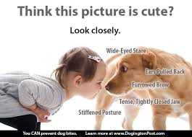

Even if they were toilet trained in their foster home, your dog is likely to have a few accidents as they settle into your new routine.

Take your rescue dog out to the garden when they arrive (on a lead) to see if they want to toilet. Most won’t go until they have settled down. Following on from this take them out to go to the toilet as soon as they wake up, after each meal and every couple of hours for the first week (every hour if a puppy) this will lessen the risk of accidents in the house and give you the opportunity to praise and reinforce all toileting outside. This will increase the likelihood they will quickly learn where they are supposed to go to the toilet and reduce the degree of accidents in the house.

Most dogs are toilet trained within 48 hours but some do take extra patience.

Possible Problems You May Encounter
Resource guarding
Separation Anxiety
House soiling
Demanding Attention
Snatching at food
Escaping
Running off
Fear of new people (growling / reactivity)
Fear of other dogs (growling / reactivity)
Counter surfing
Bin Raiding
Not liking a lead being put on
Pulling on the lead or not wanting to move when the lead is on
Reactivity outside with cars/bikes/people/sounds
Stress behaviours (Chewing / Shredding)
Digging

If there is anything you are concerned about or unsure of being able to deal with, please discuss this with us BEFORE you get agree to adopt your dog.

CONTACT US

Our opening hours are as follows. We kindly ask that you do not call outside of these hours.
- Monday 10am – 6pm
- Tuesday 10am – 6pm
- Wednesday 10am – 6pm
- Thursday 10am – 6pm
- Friday 10am – 6pm
- Saturday 10am – 4pm
- Sunday 10am – 4pm
www.phoenixrehoming.co.uk/contact

FURTHER RESOURCES

Tips on dog Socialisation https://www.amcbt.com/gallery

Online dog training clinics www.adolescentdogs.com/workshops

Trigger Stacking: http://www.woofliketomeet.com/category/about-adoption/trigger-stacking/

Introducing dogs to each other: http://www.woofliketomeet.com/2016/01/introducing-new-dogs-a-step-by-step-guide/

